Practical - 11
Practical Title: Student Management CRUD with Search and Filter Problem Definition: Create a student management module to add, view, edit, delete, search and filter student records. All database operations must use MySQL i statements and clear success/failure messages.

Theory :

1. Are SELECT, INSERT, UPDATE, and DELETE operations working?
Yes. INSERT adds a new student record, SELECT displays all student records in a table,
UPDATE edits the selected student record using an edit form, and DELETE removes a
student record. All operations use MySQLi prepared statements, and a success or failure
message is shown after each operation.

2. Is search by name/email/course implemented?
Yes. A search box sends the keyword using the GET method, and the SELECT query uses
LIKE to match the name, email or course. A course dropdown is also provided for filtering
using a WHERE condition, and search and filter can work together.

3. Are delete operations confirmed before execution?
Yes. When the user clicks the Delete button, a JavaScript confirm() dialog asks "Are you sure
you want to delete this student?". The record is deleted only when the user clicks OK.
Otherwise nothing happens.

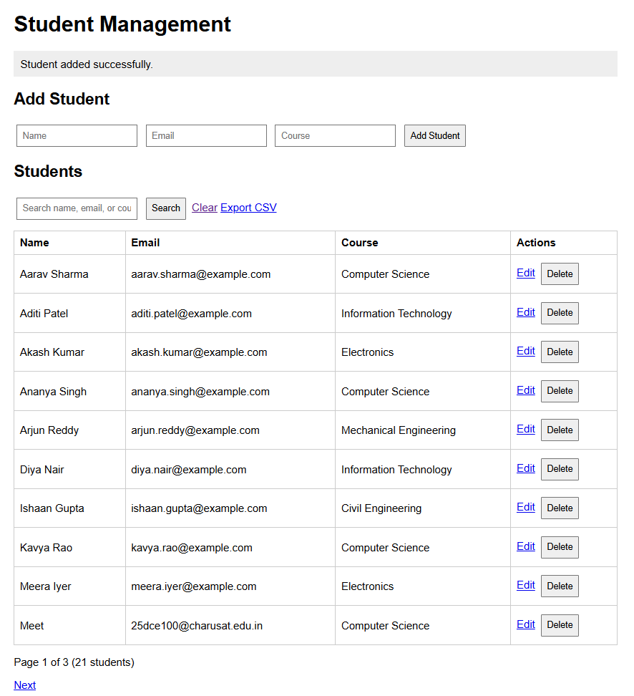

Update Student:-

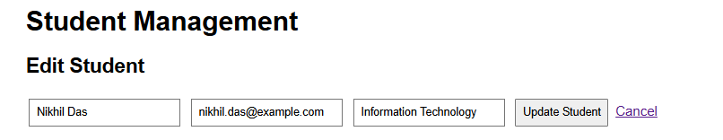

Repository Link :-
https://github.com/meet-3834/Student-Hub/tree/main/FINAL%20Submission

- Learning Outcomes:
I am able to develop a complete and secure data-management page.

Faculty Remarks: (Keep this blank for faculty)

